
Car Pollution - Buying a new car, with a “tree included”?
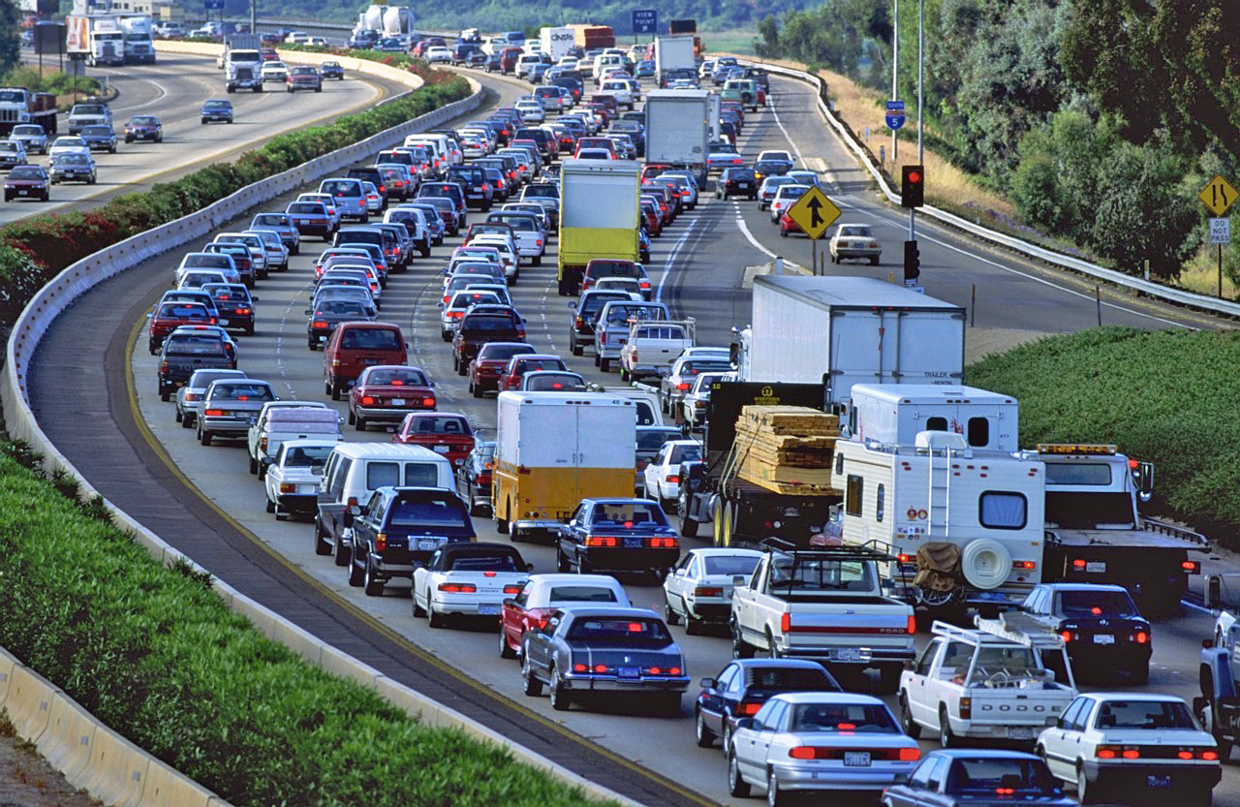
Abstract
In this activity students will explore how plants can reduce CO₂ pollution caused by cars.
Starting from an advertisement of a car manufacturer, they will critically analyse the information offered on the website and produce a report based on calculations and scientific facts.
Throughout the activity, students will carry out basic calculations (optionally, using Excel), determine statistical measures, explore the process of photosynthesis and factors influencing it, analyse and interpret graphs qualitatively, and optionally, estimate surfaces and volumes.
Aspect | Description
Mathematical content | - Statistics: measures of central tendency  - Linear functions  - Graphs  - Qualitative analysis of graphs  - Geometry: areas and volumes (optional)
Scientific content | - Photosynthesis  - Factors affecting photosynthesis: light intensity and concentration of CO₂  - Emission of CO₂  - Carbon sink species: plants  - Ecosystems
Age of students | 13-16
Number of lessons in mathematics | 4-6 lessons
Number of lessons in science | 4-6 lessons

1. Overview over the teaching unit
1.1 The situation
Before you buy a new car, it is common to surf in the web looking for prices and specifications of different cars. If you do so using the Spanish webpage of a well-known German car manufacturer, they offer you a tree as an option. You may decide whether you want to select this “optional extra” for free, or even to pay some money to plant more than one tree. This is a part of the “CO₂ neutral” programme promoted by this company, but only in Spain. There are probably other companies offering similar initiatives in your country.
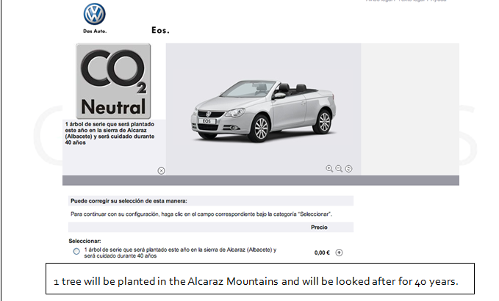
If you decide to pay for the “CO₂ neutral pack”, the website offers you additional information as follows:
“11 trees will be planted this year in the mountains of Alcaraz (Albacete). The “más árboles foundation” will take care of them for the next 40 years. These trees will compensate, over the next 40 years, for the average emissions produced by the VW Eos driving 20,000 km.”
Depending on the model and engine, between 9 and 14 trees will be planted in order to compensate for the pollution produced driving the first 20,000 km. As it is said on the webpage, you can buy additional packs if you want to compensate for extra kilometres (40,000 km, 2 packs: 60,000 km, 3 packs, etc.)
You can see an introductory video (in Spanish) at: http://www.movimientobluemotion.com/compensa/presentacion

1.2 Guiding questions
- Why is the car manufacturer interested in planting trees?
- How much pollution do cars cause?
- How can plants compensate for car pollution?
- What factors affect the capacity of a plant to absorb CO₂?
- If you had the choice, what species of tree would you choose?
- Does the situation explained before really help to compensate for the pollution produced by your new car or is it only a commercial ploy?

1.3 Final product
Write a report about the situation. Depending on your findings, decide whether, for instance, it would be worthwhile sending your report to a company in your country to join this initiative, to the company in Spain to improve the programme, to other car manufacturers to promote similar initiatives, or to the press to denounce a fraud.

1.4 Suggestions
Possible adaptations to national contexts:
- “CO₂ neutral” programme: You may consider looking for a similar programme in your country, instead of Volkswagen’s programme in Spain.
- Collection of trees: Some trees have been selected in tasks 4, 5 and 6. Students should be aware that not all the trees could be planted in their country. You could select tree species that are suitable for your country.

1.5. The task plan
The task plan indicates the interdisciplinary character of the unit and includes discipline specific questions that are related to the overarching questions. Each task is related to a specific question.
Unit | Mathematics | Science
1 | Task 1: Introducing the situation  Why is a car manufacturer interested in planting trees?
2 | Task 2: How much CO₂ do cars emit?  How is car pollution measured?  What variables are involved?  Build a model to quantify car pollution.
3 |  | Task 3: Why can plants compensate for car pollution?  Practical work using Elodea canadensis:  Why are bubbles coming from the plant?  What is the gas that is collected in the test tube?  What processes are taking place inside the plant?
4 |  | Task 4: Which factors affect the capacity of a plant to absorb CO₂?  Is the capacity of a plant to absorb CO₂ always the same?  If not, think about possible factors that might affect the capacity of a plant to absorb CO₂.  What is the relationship between light intensity and photosynthesis?
5 | Task 5: How much CO₂ can a tree compensate for? Estimating leaves’ surface area (optional).  How could you calculate the amount of CO₂ one tree can compensate for? Try to identify relevant variables in the situation.  How could you simplify the situation?  Could you estimate the amount of CO₂ a particular tree can compensate for?
6 | Task 6: Return to the initial situation.  Is the “CO₂ neutral pack” an effective strategy or just a commercial ploy?

2. Description of the tasks
2.1 Task 1 – Introduction to the overarching question
In 2010, a German car manufacturer offered the option of planting trees when you buy a new car in Spain. As advertised on their webpage and also on TV, this was part of their “CO₂ neutral programme”. There are two options: they will plant one tree for free when you buy a new car and, optionally, you can pay for extra trees (CO₂ neutral pack). You can inquire about the programme at http://www.thinkblue.es/ (note that this website is in Spanish).
The aim of this task
The aim of this activity is introduce students to the situation they will explore throughout the whole “car pollution” topic.
You should introduce the situation to your students. If an Internet connection is available, you could visit the car manufacturer’s webpage (note that only on the Spanish version of the site will you find information about the “CO₂ neutral” programme). Alternatively, use worksheet 1.1.

Activity 1 for students: introducing the situation
- Why do you think a car company is interested in planting trees?
- Why do you think they are using it as a commercial strategy?
(see worksheet 1.1)

The first contact with the information could be followed by a brainstorm session about the situation. It might give rise to interesting questions and reflections you may want to write down and use later.
A possible strategy could be to invite your students to write their reflections and questions on sheets of paper or post-it notes, collecting and classifying them according to common features. Thus, you will get valuable information about the starting point of your students, enabling you to adapt the following lessons accordingly. Moreover, you may encounter some interesting questions to be explored later.

Resources
Worksheet 1.1, Internet connection, and webpage http://www.thinkblue.es/
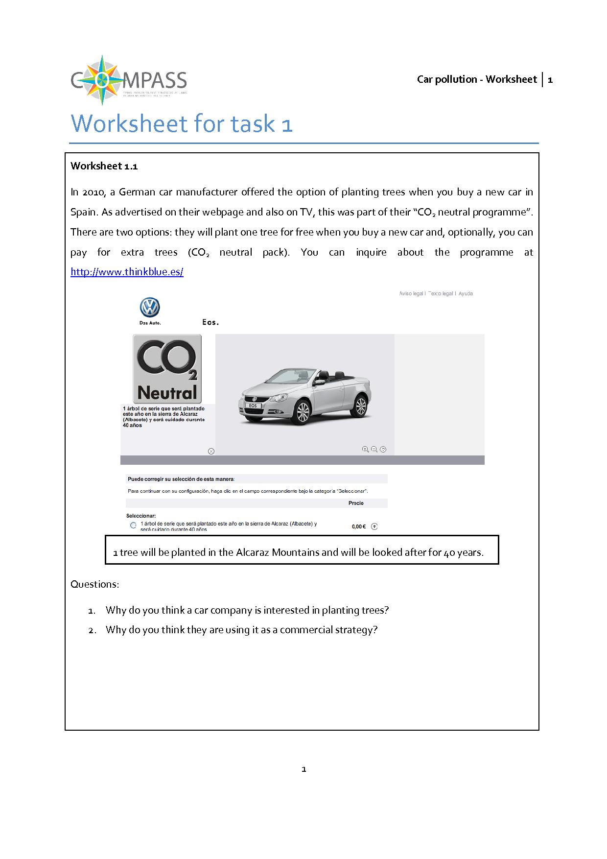
2.2 Task 2 – How much CO₂ do cars emit?
In this task students will find out about the pollution cars emit and quantify it. In order to link this task with the initial situation the task should only consider Volkswagen cars, although the results will be similar for other brands.
The aim of this task
The aim of this task is to produce a model to quantify the amount of CO₂ different cars emit over time. Students should identify relevant variables, find relationships between them, build models and work with them. Students will produce numeric (tables), graphic and/or algebraic (formulas) models, optionally using spreadsheets.
Contribution to the overall question
In order to evaluate the car manufacturer’s programme, students need to compare the pollution emitted by cars with the amount of CO₂ trees are able to compensate for. The former will be done in this task; the later will be done in those that follow.
Mathematical content
Functional relationships, linear functions, proportionality, mathematical modelling, statistics (measures of central tendency).
Scientific content
Carbon dioxide, car pollution.

Activity 1 for students: identifying variables
Take a look at the Volkswagen webpage for your country and answer the following questions.
- What is the gas cars emit?
- What are the units used to measure it?
- Could you identify a relationship between different variables?
- Which is the independent variable?
- And the dependent one?
(see worksheet 2.1)

The CO₂ emission of a car depends on multiple factors but mainly on fuel consumption (which is connected with factors like average speed). Most car manufacturers provide data on average CO₂ emissions per model and engine measured in grams per kilometre (g/km) (it is more than probable that emissions during everyday use of the car are higher).
Students should find that the variables involved are:
- Distance covered by a car (normally in km)
- CO₂ emitted (normally in g)
Let students explore the situation and make their ideas explicit. Optionally you could consider organising a brief debate about the situation.

Activity 2 for students: What is the amount of CO₂ cars emit?
The webpage provides information on how much pollution each car emits. Using these data:
Develop a mathematical model to quantify the pollution emitted by Volkswagen cars.
(see worksheet 2.2)

The situation can be modelled using linear functions, using the “rate of emission” (in g/km) as a constant of proportionality (acting as a parameter). When students start working, it should quickly emerge that it makes little sense to calculate emissions for each car model and engine, considering that the differences between two cars might not be significant. This will lead to introducing statistics.
Students may create different models, according to their preferences. Some students may prefer a graphical approach and draw a diagram while others may formulate their solutions as a table or using functions.
Resources
Worksheet 2.1, Worksheet 2.2, appendix I (for extra information), Volkswagen webpage of your country

2.3 Science – Task 3: How can plants compensate for car pollution?
By means of a hands-on experiment, students will carry out aprocedure that represents an approximation of photosynthesis. The experiment will make photosynthesis visible, enabling students to be introduced to the process and provide the motivation to study photosynthesis and the fact that it is affected by external conditions (the concentration of CO₂). This task takes a holistic approach to photosynthesis.
The aim of this task
To gain insight into photosynthesis. Students will learn that plants use CO₂ to live and grow and, as a consequence, they produce oxygen.
Contribution to the overall question
“Why do you think a car company is interested in planting trees?” That is one of the overarching questions. Throughout this activity, students will uncover the relationship between cars and trees.
Scientific content
Photosynthesis; CO₂, carbon sink species
Photosynthesis is a process in which carbon dioxide and light are combined to generate carbohydrates and oxygen. Normally, special instruments are needed to observe the process and to measure it. Usually, these instruments cannot be found in a school laboratory. However, there are some special cases in which the process is visible and some rough measurements can be made.
In this experiment, students will work with a type of aquatic plant: Elodea canadensis. The main advantage of this is that, when oxygen is produced, it gives rise to little bubbles that are visible. We can use the amount of oxygen given off by the plant as a measure of how much photosynthesis is taking place.
The experiment will make photosynthesis visible, enabling students to be introduced to the process and provide the motivation to study photosynthesis and the fact that it is affected by external conditions (concentration of CO₂, in this case). This will be the bridge to the next activity (Activity 3.2), where other factors will be explored.

Activity 1 for students: Experimenting with an aquatic plant
Carry out the following experiment with Elodea canadensis
Write down any ideas, reflections, insights or whatever you find interesting or challenging whilst you are carrying out the experiment.
(see worksheet 3.1)
Students can work in groups exploring the situation and formulating a hypothesis. Give students enough time to carry out the experiment in the three different versions, to observe phenomena, to formulate hypothesis, to try to explain them, and to discuss and argue points with each other. The teacher should promote and manage collaborative classroom discussion and reflections about CO₂ consumption.

Once the experiment has been carried out, students should communicate their findings to each other and debate the issues raised.

Activity 2 for students: Sharing findings, communicating and debating results.
- What do you think the bubbles are?
- What is the gas that has been collected in the test tube?
- Was the number of bubbles significantly different in the three experiments?
- What could be a possible reason for the different number of bubbles collected in the test tubes?
(see worksheet 3.2)

In order to promote discussion and debate, you could organise a plenary where students explain and defend their findings. Another possible strategy is to let students organise their findings in a “scientific poster” and have a poster session (such as would be found at a scientific conference).
You might also consider asking students to prepare a brief PowerPoint presentation to communicate and debate their findings.
By the end, students should know that what is happening in the plant is photosynthesis.
This process can be described in a very simplified way as:
Light + water + carbon dioxide → sugar + oxygen
Through a non-balanced equation using chemical symbols:
Light + H₂O + CO₂→ Sugar + O₂
Or even using the balanced chemical equation:
6 CO₂ + 6 H₂O + photons → C₆H₁₂O₆ + 6 O₂
Different misconceptions may appear when students present their ideas (for instance, that the bubbles are “air” or CO₂). By the end it should be clear that the bubbles are mainly oxygen and that there is a relation between carbon dioxide concentration and the quantity of oxygen produced in photosynthesis.

Resources
Worksheet 3.1, Worksheet 3.2, Appendix II (for a more detailed description of the experiment), Appendix III (for extra information)
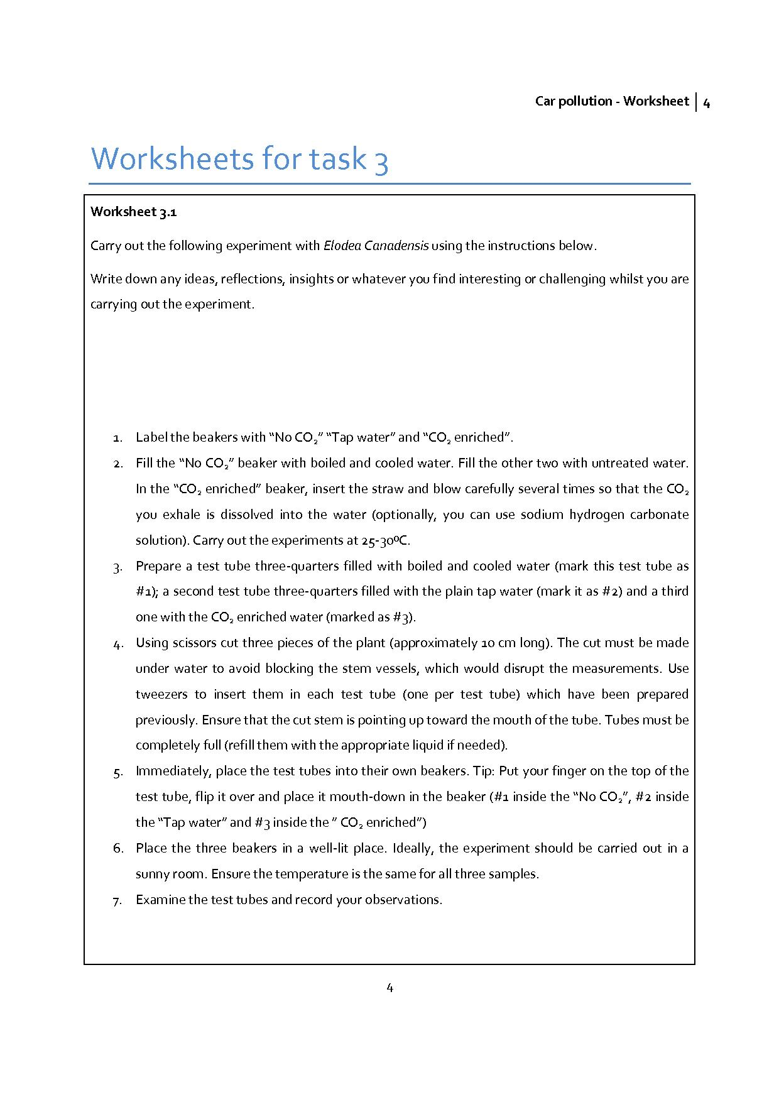
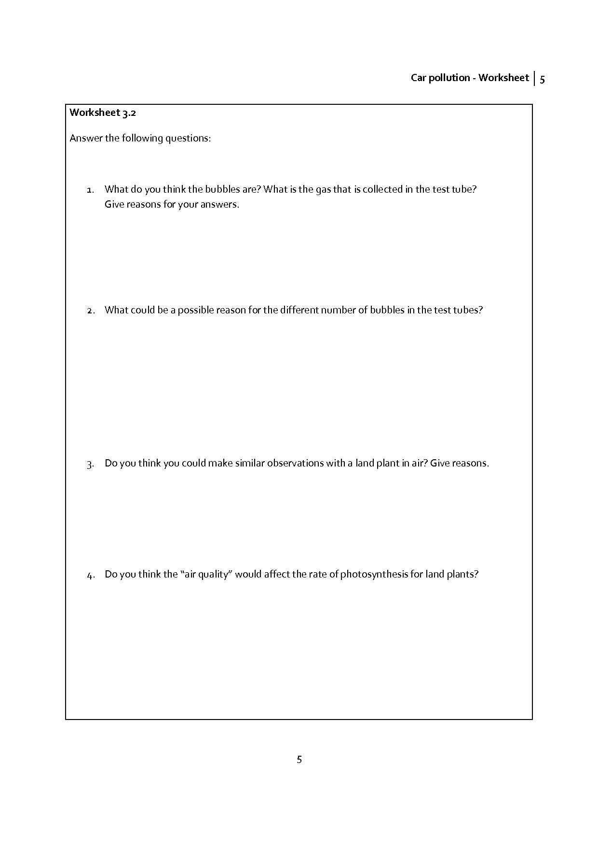
2.4 Task 4 – Science and Mathematics. Which factors affect the capacity of a plant to absorb CO₂?
In the previous task, students gained a holistic introduction to photosynthesis. They have also explored one factor that affects photosynthesis: concentration of CO₂ in the plant’s environment. Now students should explore other variables that may also affect photosynthesis.
The aim of this task
- To identify other factors that may affect photosynthesis
- To gain a deeper understanding of the dependency of photosynthesis on light intensity
- To interpret graphs qualitatively
- To distinguish between photosynthesis and photorespiration
- (Optionally) To learn about C3 and C4 plants
Contribution to the overall question
This activity will provide a deeper understanding about photosynthesis.
Mathematical content
Qualitative analysis of graphs: direct proportionality, interception with axes, maximum points, domain and range.
Scientific content
- Factors affecting photosynthesis.
- Relationship between light intensity and photosynthesis.
- Types of plants : C3 and C4 (optional)

Activity 1 for students: Factors affecting photosynthesis
- Do you think that the capacity of a plant to absorb CO₂ is always the same?
- If not, think about possible factors that might affect a plant’s capacity to absorb CO₂.
(see worksheet 4.1)

Initially, it is expected that students would consider, among others,light (intensity), time or plant size.
It is important to ask students not only to identify possible factors, but also to provide reasons for their suggestions. In this way, significant concepts should emerge and possible misconceptions should be uncovered.
The teacher may decide to use group work to promote students’ reflection as follows:
- Pupils working in small groups to identify possible factors.
- Pupils could write their proposals on Post-It notes and presenting their ideas to the group.
- Students could group Post-It notes containing similar factors and writing a preliminary hypothesis (whole class guided by the teacher).
Among the different factors that may emerge from the previous activity, students should explore the relationship between light intensity and photosynthesis. Activity 4.2 gives students the opportunity to explore this relationship using an applet (further information may be found in appendices IV and V). When introducing the activity, a brief explanation about how the applet works should be given to students. It may be preferable not to show graphs in advance, in order to avoid influencing students’ answers to the first few questions. Attention should also be drawn to how each graph represents the dependency between light intensity and the capacity of each plant species to absorb CO₂.

Activity 2 for students: light intensity and photosynthesis
- Broadly speaking, what are the graphs telling you about the relationship between light intensity and CO₂ absorption?
- Cut out the cards (picture + graph) and try to group them according to common features. Explain why you have chosen these groups.
- Could you explain in more detail the common features of the relationship between light intensity and CO₂ absorption for the plants you have grouped together?
- Why are there negative values on the graphs (vertical axis)?
(see worksheet 4.2)
Students should notice that:
Photosynthesis depends on light intensity.
This dependency is,broadly, directly proportional.
But the dependency saturates at some points: for some species, there is an asymptotic behaviour, while for others, a maximum value may be reached after which, a decrease in their efficiency at capturing CO₂ occurred for higher light intensities.
You may decide whether you want to go further into leaf anatomy to explain these two different behaviours.
Further information can be found in the appendices.
Resources
Worksheet 4.1, worksheet 4.2, Appendix IV (cards), Appendix V
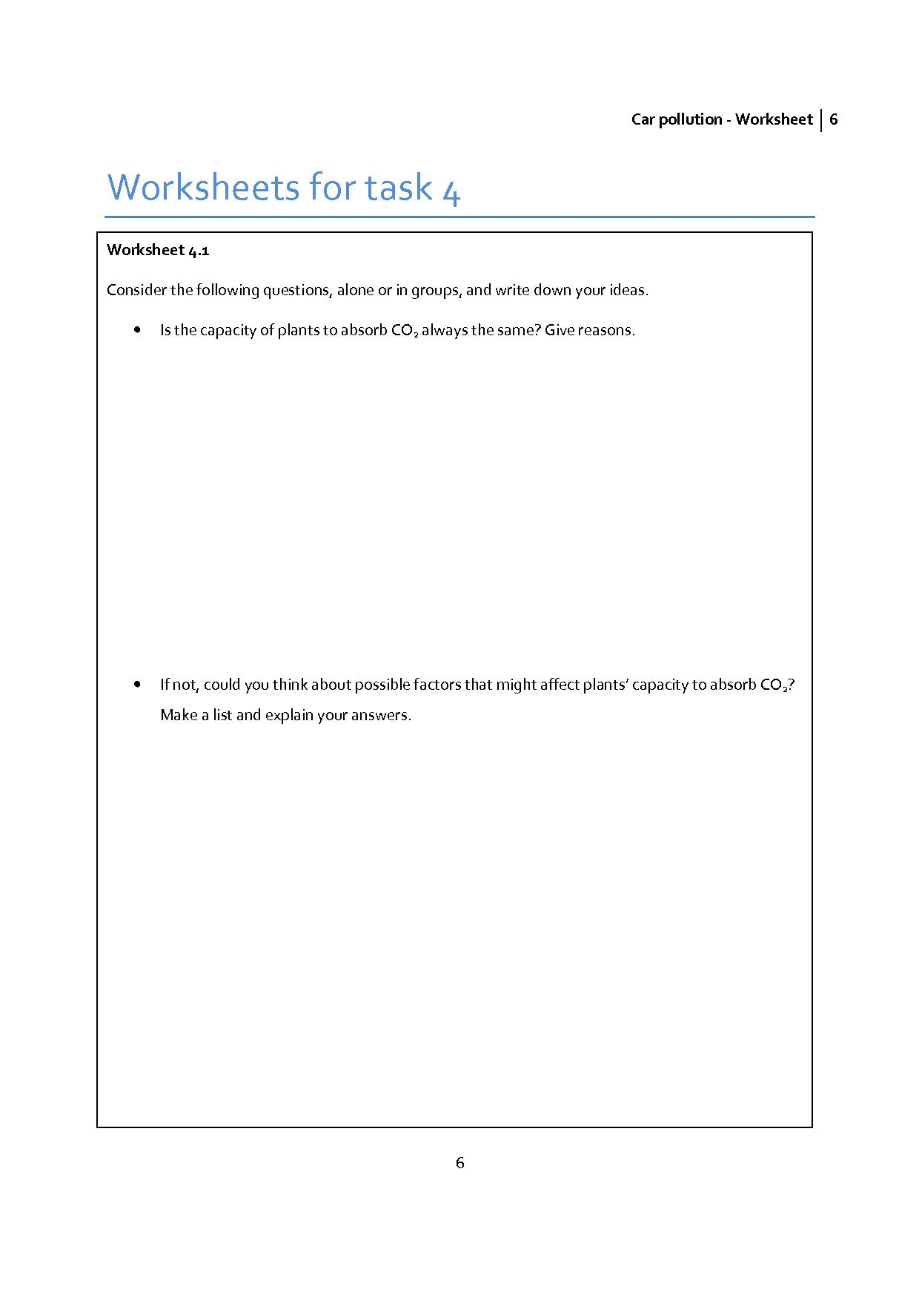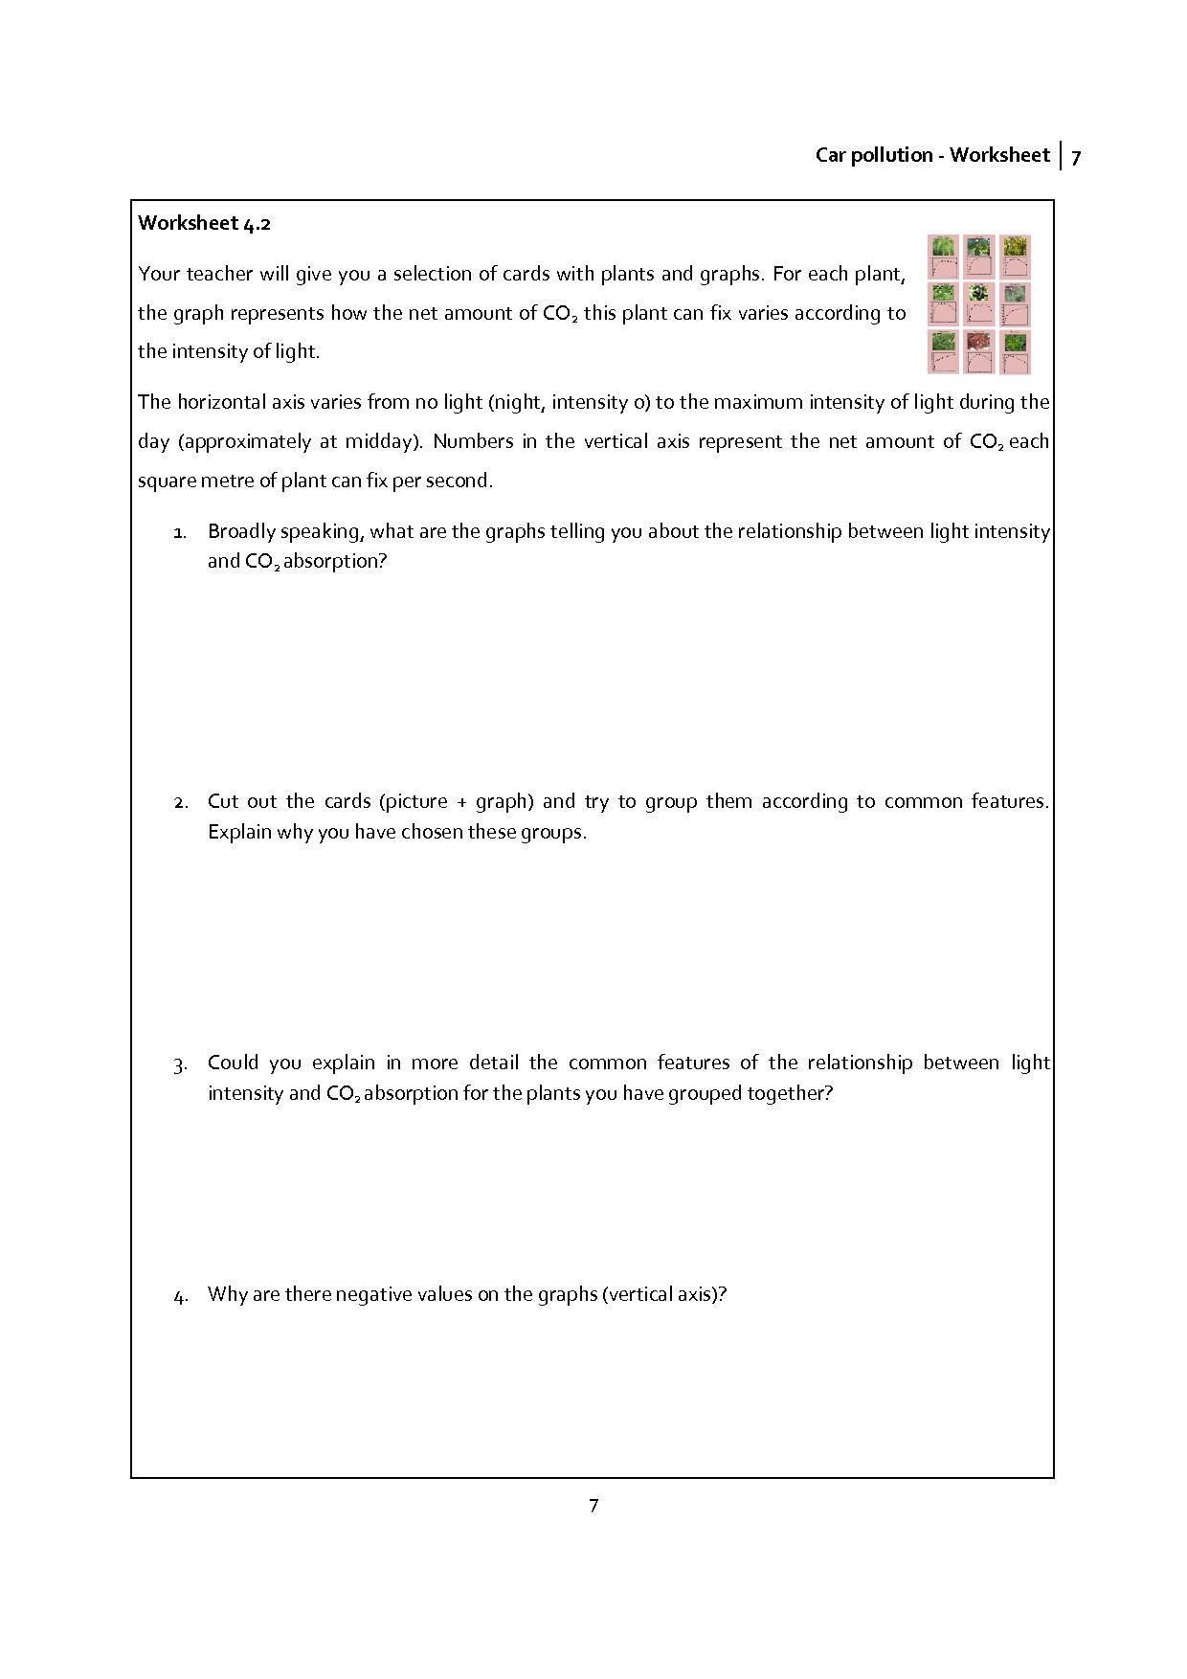
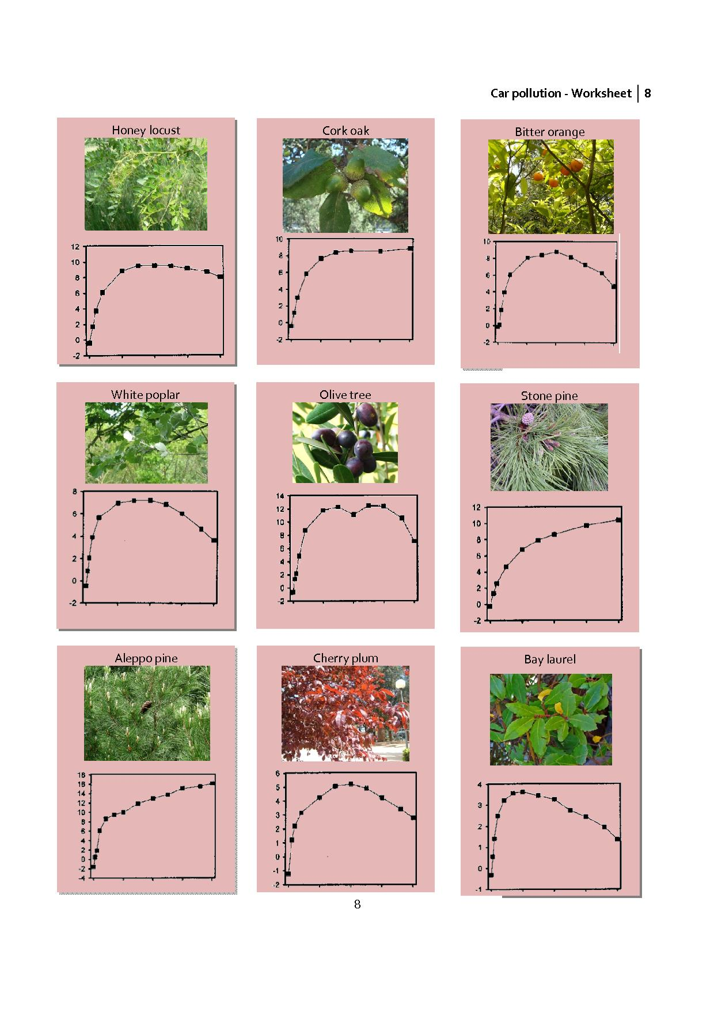
2.5 Task 5 – How much CO₂ can a tree compensate for? Estimating leaves’ surface area.
This is an optional activity, due to its complexity. The point of interest, but also difficulty, is to estimate the total surface area of a tree’s leaves.
The aim of this task
- To calculate the amount of CO₂ one tree can compensate for.
- To estimate the total surface area of a tree’s leaves.
Contribution to the overall question
Students have already calculated in task 2 the quantity of CO₂ emitted by cars. Estimating the amount of CO₂ that trees can compensate for is the next step in evaluating the overall question.
Mathematical content
- Modelling
- Geometric shapes and forms
- Surface and volume
Scientific content
- Trees’ physiognomy.
- Different species of trees.

If possible, identify a tree near to school. It is important to choose one of the species listed in the table (worksheet 5.2), unless you have access to additional data. Optionally, students could take a picture (or look for one on the internet) and use it to make their estimate.

Activity 1 for students: Leaf surface area of a tree
- Estimate a tree’s leaf surface area.
(see worksheet 5.1)

Students will be involved in a geometrical modelling activity: identifying geometric forms, estimating quantities, calculating surfaces and volumes, interpreting results, validating, etc.
Possible approaches:
- Modelling the surface area of a tree’s leaves via a geometric form (cuboid, ball, etc.)
- Modelling the surface of a single leaf and estimating the number of leaves on a tree
Once they obtain an estimate, students can approximate how much CO₂ a tree could compensate for.

Activity 2 for students: CO₂ consumption
- Calculate how much CO₂ one tree could compensate for.
(see worksheet 5.2)

Data about the rate of photosynthesis for different species are provided on worksheet 5.2. If you have decided to work with a different species, additional data will be necessary.
Resources
Worksheet 5.1, Worksheet 5.2, Appendix VI (for extra information)

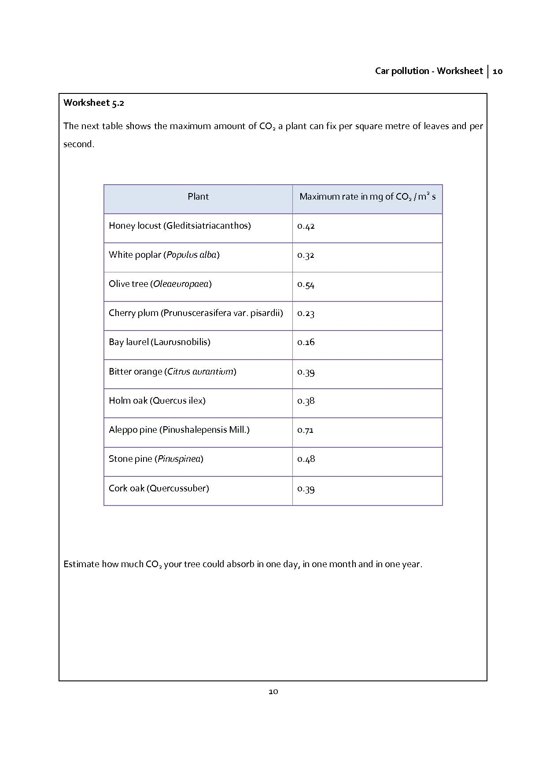
2.6 Task 6 – Final task: Return to the initial situation
This is the final task, bringing together students’ work on car pollution, photosynthesis and CO₂ reduction in order to evaluate the car manufacturer’s advertisement. Two statements made by the car manufacturer on its web page will be studied further and the truth of the statements will be evaluated.
The aim of this task
To evaluate, using scientific arguments, the information provided by the car manufacturer.
To communicate about the issues using scientific arguments and data.
Contribution to the overall question
In this activity students will use the knowledge they have acquired and the data they have gathered and analysed to evaluate the initial situation. They will produce a report addressing the question:
Does the programme presented on the car manufacturer’s webpage really help to compensate for the pollution produced by your new car or is it only a commercial ploy?
Mathematical content
- Modelling (mainly interpreting and validating)
- Proportionality
Scientific content
- CO₂ pollution
- Carbon sink species
- Photosynthesis
In task 2 students calculated how much CO₂ one car emits per kilometre. If you have used task 5, they also know how much CO₂ one tree can absorb. If you decided to skip this task, you should provide students with the table in appendix VII. This table shows the net rate of photosynthesis of different trees. It is important to consider that these data have been estimated for an individual tree of each species (estimating their biomass and leaf surface). Obviously, data will vary significantly for smaller or bigger trees.

Activity 1 for students: Evaluating the first statement.
- The manufacturer’s webpage states that: “One tree included, for free”. The tree will compensate for the CO₂ emissions of your car in its first 20,000 kilometres of use”. Is this really possible?
- (see worksheet 6.1)
Activity 2 for students: Evaluating the second statement.
- The manufacturer’s webpage states that: “Optional CO₂ neutral pack”. Between 9 and 14 trees will be planted to compensate for the pollution caused by your car for each 20,000 km travelled. Is this really possible?
- (see worksheet 6.2)

As a suggestion, you could ask your students to produce a poster or PowerPoint presentation with their findings. Finally, a brief presentation of their results and class debate will give students the opportunity to argue and discuss using scientific arguments.
Resources
Worksheet 6.1, Worksheet 6.2, Appendix VII


3. Appendix

Appendix I: Extra information – task 2
The aim of this modelling process is to quantify the amount of CO₂ a car emits over time. Students should identify relevant variables, find relationships between them, build models and work with them. These models could be numeric (tables), graphic and/or algebraic (formulas). Spreadsheets are anideal tool to produce these models, to connect them together, to make it easier to work with variables and parameters, to make predictions, to optimise the models, to validate hypothesis, etc.
Every modelling process implies a simplification of the situation in question. Normally, some variables are chosen to the detriment of others. At this point, it is important to give students enough time to explore the situation and to identify relevant variables themselves.
Activity 2.1: Identifying variables
The CO₂ emission of a car depends on multiple factors but mainly on fuel consumption (which is connected with factors like average speed). Most car manufacturers provide data on average CO₂ emissions per model and engine measured in grams per kilometre (g/km) (it is more than probable that emissions during everyday use of the car are higher).
Working with this data, the variables involved are:
Distance covered by a car (normally in km).
CO₂ emitted (normally in g).
The situation can be modelled using linear functions, using the “rate of emission” (in g/km) as a constant of proportionality (acting as a parameter).
Activity 2.2: Looking for representative values and modelling CO₂ emissions
The first issue arises when trying to determine the value of this parameter (the “rate of emissions”). If students choose a specific car model with a specific engine, it is a simple enough task to look up the data from the manufacturer’s webpage. However, trees are planted for every model produced by the manufacturer, meaning that emissions from any model and with any engine should also be considered. These data are accessible through the official webpage of the manufacturer and will give rise to a vast data set.
One case will be presented here to illustrate the work that should be aimed for. For instance, for a VW EOS, the following Excel table shows some of these calculations.
 | Model VW EOS
 | 1.4 TSI 122 CV | 1.4 TSI 160 CV | 2.0 TSI 200 CV | 3.6 V6 FSI 260 CV | 2.0 TDI 140 CV
g/km --> | 154 | 159 | 178 | 214 | 159
km
1000 | 154000 | 159000 | 178000 | 214000 | 159000
2000 | 308000 | 318000 | 356000 | 428000 | 318000
3000 | 462000 | 477000 | 534000 | 642000 | 477000
4000 | 616000 | 636000 | 712000 | 856000 | 636000
5000 | 770000 | 795000 | 890000 | 1070000 | 795000
6000 | 924000 | 954000 | 1068000 | 1284000 | 954000
7000 | 1078000 | 1113000 | 1246000 | 1498000 | 1113000
8000 | 1232000 | 1272000 | 1424000 | 1712000 | 1272000
9000 | 1386000 | 1431000 | 1602000 | 1926000 | 1431000
10000 | 1540000 | 1590000 | 1780000 | 2140000 | 1590000
11000 | 1694000 | 1749000 | 1958000 | 2354000 | 1749000
12000 | 1848000 | 1908000 | 2136000 | 2568000 | 1908000
13000 | 2002000 | 2067000 | 2314000 | 2782000 | 2067000
14000 | 2156000 | 2226000 | 2492000 | 2996000 | 2226000
15000 | 2310000 | 2385000 | 2670000 | 3210000 | 2385000
16000 | 2464000 | 2544000 | 2848000 | 3424000 | 2544000
17000 | 2618000 | 2703000 | 3026000 | 3638000 | 2703000
18000 | 2772000 | 2862000 | 3204000 | 3852000 | 2862000
19000 | 2926000 | 3021000 | 3382000 | 4066000 | 3021000
20000 | 3080000 | 3180000 | 3560000 | 4280000 | 3180000
21000 | 3234000 | 3339000 | 3738000 | 4494000 | 3339000
22000 | 3388000 | 3498000 | 3916000 | 4708000 | 3498000
23000 | 3542000 | 3657000 | 4094000 | 4922000 | 3657000
24000 | 3696000 | 3816000 | 4272000 | 5136000 | 3816000
25000 | 3850000 | 3975000 | 4450000 | 5350000 | 3975000
26000 | 4004000 | 4134000 | 4628000 | 5564000 | 4134000
27000 | 4158000 | 4293000 | 4806000 | 5778000 | 4293000
28000 | 4312000 | 4452000 | 4984000 | 5992000 | 4452000
29000 | 4466000 | 4611000 | 5162000 | 6206000 | 4611000
30000 | 4620000 | 4770000 | 5340000 | 6420000 | 4770000

These data can be presented as graphs using Excel, which allows a visual comparison. The example shows clearly that it makes little sense to calculate emissions for each car model and engine, considering that the differences between two cars are not particularly significant. Although your students are working with different cars, the conclusion will be the same.
Then, the next task should be to determine one or several representative values for the “rate of emission”. For instance:
- Calculating the arithmetic mean (or the median, or the mode) of all the data.
- Calculating the arithmetic mean (or the median, or the mode) of the most popular models of this manufacturer.
However, depending on the statistical spread of data, questionssuch as “could a single measure represent the whole set of data?” may emerge, giving rise to different strategies such as, for instance, grouping cars in intervals (low, medium, and high emissions) and taking a representative value for each one.
For instance, just to show an example, students may consider the following classifications:
- Low emissions cars - 100 g/km
- Medium emissions cars - 150 g/km
- High emissions cars - 200 g/km
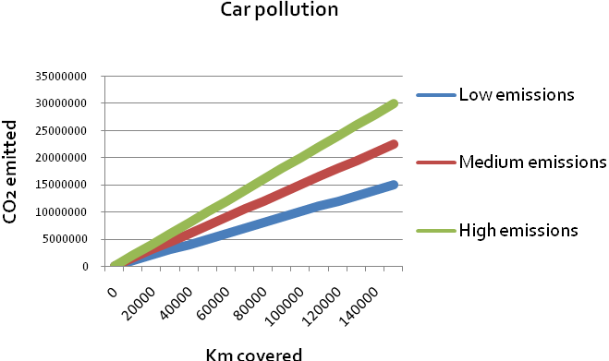
To summarise, the aims of this first part are:
- To identify relevant variables and dependencies
- To consider that the important issue is not to calculate the emissions for each car model and engine, but to find a way to represent the vast array of data and how to find representative values for them.
- To calculate emissions produced by cars and to develop models (tables, graphs and/or formulas).
- Results obtained here will be taken up again at the end of the project in order to produce the final report, once the amount of CO₂ a tree can compensate for has been investigated.
Appendix II: Experiment using Elodea Canadensis – task 3
Photosynthesis is a process in which carbon dioxide and light are combined to generate carbohydrates and oxygen. Normally, special instruments are needed to observe the process and to measure it. Usually, these instruments cannot be found in a school laboratory. However, there are some special cases in which the process is visible and some rough measurements can be made.
In this experiment, students will work with a type of aquatic plant: Elodea canadensis. The main advantage of this is that, when oxygen is produced, it produced little bubbles that are visible. We can use the amount of oxygen given off by the plant as a measure of how much photosynthesis is taking place.
In some versions of this experiment, baking soda is used in order to get a higher concentration of CO₂. You can explore this option, but consider that extra bubbles may appear and they must be removed before the experiment starts. We will suggest other ways of increasing the CO₂ concentration in water, such as using exhaled air throughout straws.
Students should work in groups and share their observations and conclusions at the end of the experiment. The teacher should promote and manage collaborative classroom discussion and reflections about CO₂ consumption.
Lab materials
Plant Elodea Canadensis, beakers (250 ml), test tubes (30 mm Ø), water, sodium hydrogen carbonate solution (10 % w/v), tweezers, scissors, straws

Safety procedures
Review safety procedures relating to: Clean up of spills, handling liquids, handling solids (weighing) (only if students will be preparing the NaHCO₃ solution), safety data sheet for sodium hydrogencarbonate (CAS No.: 144-55-8)

Procedure
- Label the beakers with “No CO₂” “Tap water” and “CO₂ enriched”.
- Fill the “No CO₂” beaker with boiled and cooled water. Fill the other two with untreated water. In the “CO₂ enriched” beaker, insert the straw and blow carefully several times so that the CO₂ you exhale is dissolved into the water (optionally, you can use sodium hydrogen carbonate solution). Carry out the experiments at 25-30ºC.
- Prepare a test tube three-quarters filled with boiled and cooled water (mark this test tube as #1); a second test tube three-quarters filled with the tap water (mark it as #2) and a third one with the CO₂ enriched water (marked as #3).
- Using scissors cut three pieces of the plant (approximately 10 cm long). The cut must be made under water to avoid blocking the stem vessels, which would disrupt the measurements. Use tweezers to insert them in each test tube (one per test tube) which have been prepared previously. Ensure that the cut stem is pointing up toward the mouth of the tube. Tubes must be completely full (refill them with the appropriate liquid if needed).
- Immediately, place the test tubes into their own beakers. Tip: Put your finger on the top of the test tube, flip it over and place it mouth-down in the beaker (#1 inside the “No CO₂”, #2 inside the “Tap water” and #3 inside the ” CO₂ enriched” beakers)
- Place the three beakers in a well-lit place. Ideally, the experiment should be carried out in a sunny room. Ensure the temperature is the same for all three samples.
- Examine the test tubes and record your observations.

Appendix III: Extra information – task3
Students will carry out a procedure that represents an approximation of photosynthesis.
Activity 1: Experimenting with Elodea canadensis
The first task suggested from the science side will be a hands-on experiment that will allow students to gain an insight about photosynthesis.
It is a well-known experiment done with a species of aquatic plant: Elodea canadensis. The experiment is described in the “materials” section, at the end of this booklet.
When the plant is submerged under water, oxygen generated during photosynthesis (mixed with other compounds) is visible in the form of bubbles.
This could prompt questions such as:
Why are bubbles coming out from the plant?
What is the gas that is collected in the test tube?
What are the processes taking place inside the plant?
Students can work in groups exploring the situation and formulating a hypothesis. As described in the “materials” section, students will explore the situation in three different environments: boiled water (almost no CO₂), tap water (low CO₂ concentration) and CO₂ enriched water.
Activity 2: Sharing findings, communicating and debating
Once the experiment has been carried out, students should communicate their findings to each other and debate the issues raised.
By the end, students should know that what is happening in the plant is photosynthesis.
This process can be described in a very simplified way as
Light + water + carbon dioxide → sugar + oxygen
Through a non-balanced equation using chemical symbols
Light + H₂O + CO₂→ Sugar + O₂
Or even the balanced chemical equation
6 CO₂ + 6 H₂O + photons → C₆H₁₂O₆ + 6 O₂
In any case it is important in this point to be aware about a common misconception students’ develop: the oxygen produced in the photosynthesis comes directly from the CO₂ molecule. That is, during the photosynthesis the CO₂ molecule is divided into two different parts: the carbon atoms go somewhere and the oxygen molecules are excreted into the atmosphere. This misconception is normally reinforced by simplified formulas like “Light + water + CO₂ → Sugar + O₂”. It may be interesting therefore to ask your students about this in order to determine if this misconception is emerging. This will enable you to react accordingly.
The experiment renders photosynthesis visible, enabling students to be introduced to the process and provide the motivation to study photosynthesis and the fact that it is affected by external conditions (concentration of CO₂, in this case). This will be the bridge to the next activity, where other factors will be explored.
Some pedagogical guidelines
Allow students enough time to carry out the experiment in the three different versions, to observe phenomena, to formulate a hypothesis, to try to explain them, and to discuss and debate.
In order to promote discussion and debate, you could organise a plenary where students explain and defend their findings.
Another possible strategy is to let students organise their findings as a “scientific poster” and have a poster session (such as would be found at a scientific conference).
You might also consider asking students to prepare a brief PowerPoint presentation to communicate and debate their findings.
Some guiding questions you might use (included in the students’ worksheet):
What do you think the bubbles are? What is the gas that is collected in the test tube? Give reasons for your answers.
Is the number of bubbles significantly different for the three experiments?
Do you think that “water quality” affects the rate of photosynthesis for aquatic plants?
Do you think these observations should be carried out with a land plant? Give reasons.
Do you think the “air quality” would affect the rate of photosynthesis for land plants?
Appendix IV: Cards – task 4 (activity 4.2)
Cork oak

Bitter orange

White poplar

Olive tree

Stone pine

Aleppo pine

Cherry plum

Bay laurel

Honey locust

Appendix V: Extra information – task 4
In the previous task, students gained a holistic introduction to photosynthesis. They have also explored one factor that affects photosynthesis: concentration of CO₂ in the plant’s environment. Now students should explore other variables that may also affect photosynthesis.
Activity 4.1: brainstorming
A good starting point might be a brainstorming session. Guiding questions could be:
- Is the capacity of plants to absorb CO₂ always the same?
- If not, could you think about possible factors that might affect plants’ capacity to absorb CO₂?
Initially, it is expected that students would consider, among others:
- Light (intensity)
- Time
- Plant size
It is important to ask students not only to identify possible factors affecting photosynthesis, but also to provide reasons for their suggestions. In this way, significant concepts should emerge and possible misconceptions should be uncovered.
Activity 4.2: light intensity and photosynthesis
The aim of this activity, from the science perspective, is not to establish the relationship between light intensity and photosynthesis, but:
- To identify whether the relationship is proportional.
- To infer the existence of two different kinds of plants, depending on their behaviour in relation to irradiation from sunlight.
A possible starting point for this activity could be an initial brainstorming session guided by questions like “Does light affect photosynthesis? Could you sketch a graphshowing the effect of light intensity on photosynthesis?” Initially, it is expected that students should sketch qualitative graphs, mainly linearly proportional.
Next, a selection of graphs will be given to the students. Each graph shows the relationship between light intensity and the net amount of CO₂ captured by different types of plants. Data have been taken from a scientific survey published by the University of Seville.
Organise students into groups (3-4 students per group) and give them a copy of the graphs (Appendix IV). Introduce the situation explaining that each graph corresponds to a different kind of plant but that all the graphs are modelling the dependency between light intensity and the capacity of the plant to absorb CO₂. Give students enough time to work with the graphs, to identify similarities and differences and to give an answer to the questions (listed in their worksheet as well):
- Broadly speaking, what are the graphs telling you about the relationship between light intensity and CO₂ absorption?
- Cut out the cards (picture + graph) and try to group them according to common features. Explain why you have chosen these groups.
- Could you explain in more detail the common features of the relationship between light intensity and CO₂ absorption for the plants you have grouped together?
- Why are there negative values on the graphs (vertical axis)?
It is expected that students should be able to identify an increasing dependency: the higher the light intensity is, the larger the CO₂ amount the plant can absorb is. However, some students will notice that not all plants behave in the same way at high levels of light intensity. Indeed, this is the point we want them to discover when they put the graphs into groups. Obviously, other classification might arise: for instance, depending on the net amount of CO₂ the plant can fix (low – medium –high).
At the end, the conclusions students should draw and you must clearly set are:
- Photosynthesis depends on light intensity.
- This dependency is broadly, directly proportional.
- But the dependency saturates at some points: for some species, there is an asymptotic behaviour, while for others, a maximum value may be reached after which, a decrease in their efficiency at capturing CO₂ occurred for higher light intensities.
You may decide whether you want to go further into leaf anatomy to explain the difference between these two behaviours, just giving a brief explanation or even letting your students study this topic in greater detail.
Background information about the context/content
In the graphs:
- The horizontal axis corresponds to light intensity, measured in μmole of photons per square metre per second. The range is between 0 (night) and 2500 μmole of photons/m²·s (representing the maximum intensity in the city where the measurements were taken, at approximately midday).
- The vertical axis corresponds to the net amount of CO₂ captured by a square metre of this plant species in a second (measured in μmole of CO₂ /m²·s). That means that photorespiration has also been included, explaining why graphs show a negative amount of CO₂ captured at very low light intensities.
Working with these units might be difficult for your students. That’s why, on the cards (Appendix IV), the scale in the horizontal axis has been omitted and a qualitative description (varying from no light to maximum light intensity during the day) is recommended. Units have been omitted on the vertical axis as well. If you think your students can deal with these units, you may introduce them.
Another important remark is that two different kinds of graphs, corresponding to two different plant species, have been selected:
- C3 plants, in which the absorption of CO₂ decreases with very high light intensity (due to the shutting of their stomata to reduce water loss).
- C4 plants, in which CO₂ absorption increases up to a point of saturation but never decreases (due to their special leaf anatomy that makes them more effective in water stress environments and high temperatures).
Appendix VI: Extra information – task 5
In this task, the objective is to calculate the amount of CO₂ one plant can absorb. You can use the plants and data that have been explored in the previous section or new ones (as long as you have access to some basic data).
The point of interest, but also difficulty, is to estimate the total surface area and biomass of a tree. That is why we are proposing this activity as purely optional.
If you want to explore this activity, it is a good idea to identify some trees near to school that could be approximated by geometric forms: cylinders, cones, spheres or a combination thereof. If not, you can ask students to work from a picture or look for pictures or data on the Internet.
Students will be involved in a geometrical modelling activity: identifying geometric forms, estimating quantities, calculating surfaces and volumes, interpreting results, validating, etc.
The combination of these calculations with the data presented on worksheet 5.2, extracted from the graphs studied previously, will be enough to estimate how much CO₂ each plant could fix per day. We have decided to convert µmoles into milligrams in order to make it easier for students.
Issues about photosynthetic efficiency and light intensity might arise here. For instance, that light intensity is not the same throughout the day and, of course, it depends on the season. That could lead to interesting discussions about structuring and simplifying processes that every modelling activity should deal with.
Appendix VII: Extra information – task 6
This is the final task, bringing together students’ work on car pollution, photosynthesis and CO₂ reduction in order to evaluate the car manufacturer’s advertisement.
In this final task, two statements made by the car manufacturer on its web page will be studied further and the truth of the statements will be evaluated. These statements are:
1st statement: “One tree included, for free. The tree will compensate for the CO₂ emissions of your car in its first 20,000 kilometres of use.”
2nd statement: “Optional CO₂ neutral pack”. Between 9 and 14 trees will be planted to compensate for the pollution caused by your car for each 20,000 km travelled.
In task 2, students calculated how much CO₂ one car emits. If you have used task 5, they also know how much CO₂ one tree can absorb. If you decided to skip this task, the table provided in this appendix offers the data your students will need.
Plant | Net rate of photosynthesis (g CO₂ per day)
Plant | Winter | Spring – Autumn | Summer
Honey locust (Gleditsia triacanthos) | 0 | 3.2 | 3.3
White poplar (Populus alba) | 0 | 1.9 | 1.6
Olive tree (Olea europaea) | 1.03 | 1.8 | 1.6
Cherry plum (Prunus cerasifera var. pisardii) | 0 | 66 | 53
Bay laurel (Laurus nobilis) | 0.8 | 1.2 | 1
Bitter orange (Citrus aurantium) | 1 | 1.8 | 1.5
Holm oak (Quercus ilex) | 9 | 15 | 17
Aleppo pine (Pinus halepensis Mill.) | 74 | 149 | 171
Stone pine (Pinus pinea) | 44 | 85 | 88
Cork oak (Quercus suber) | 7.6 | 14.4 | 14.1

This table shows the net rate of photosynthesis of different trees (Figueroa & Redondo, 2007). It is important to consider that these data have been estimated for anindividual tree of each species (estimating their biomass and leave surface). Obviously, data will vary significantly for smaller or bigger trees.
Some considerations about students’ final results:
- Some students may say that it is not possible to make the calculations because all the trees planted may not be the same as the one used in the calculations. Moreover, they could argue that trees will be very small during their first few years. This is a good opportunity to discuss the modelling cycle and the process of simplification.
- Depending on the tree they chose, some students may find that the CO₂ fixed at the end is not enough for the total amount a car emits, whilst others will find the opposite (especially if they decide to plant only Allepo pine). This is a good opportunity to introduce the issue of biodiversity and ecology. The forest is in the south-east of Spain, in an area with a Mediterranean climate (Mediterranean forest). That means that all the trees in the table are inappropriate for this area. Our choice of trees has not been made by chance. There are only 5 trees typical of a Mediterranean forest: olive tree, holm oak, allepo pine, stone pine and cork oak. The problem of biodiversity and the adaptation of the trees to the environment could be introduced into the debate.

