
Worksheet for task 1
Worksheet 1.1
In 2010, a German car manufacturer offered the option of planting trees when you buy a new car in Spain. As advertised on their webpage and also on TV, this was part of their “CO₂ neutral programme”. There are two options: they will plant one tree for free when you buy a new car and, optionally, you can pay for extra trees (CO₂ neutral pack). You can inquire about the programme at http://www.thinkblue.es/
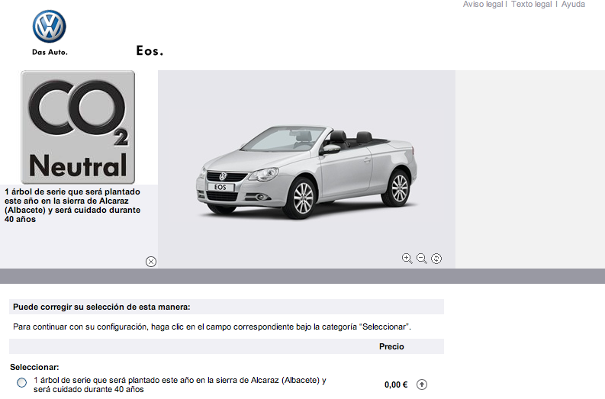
1 tree will be planted in the Alcaraz Mountains and will be looked after for 40 years.
Questions:
- Why do you think a car company is interested in planting trees?
- Why do you think they are using it as a commercial strategy?

Worksheets for task 2
Worksheet 2.1
In this task you will find out about the pollution cars emit and quantify it. In order to link this task with the initial situation, you should only consider Volkswagen cars, although the results will be similar for other brands.
Take a look at the Volkswagen webpage for your country and answer the following questions.

- What is the gas cars emit?

- What are the units used to measure it?

- Could you identify a relationship between different variables? If so, which is the independent variable? And the dependent one?

Worksheet 2.2
The webpage provides information on how much pollution each car emits.
Using these data:
Develop a mathematical model to quantify the pollution emitted by Volkswagen cars.

Worksheets for task 3
Worksheet 3.1
Carry out the following experiment with Elodea Canadensis using the instructions below.
Write down any ideas, reflections, insights or whatever you find interesting or challenging whilst you are carrying out the experiment.

- Label the beakers with “No CO₂” “Tap water” and “CO₂ enriched”.
- Fill the “No CO₂” beaker with boiled and cooled water. Fill the other two with untreated water. In the “CO₂ enriched” beaker, insert the straw and blow carefully several times so that the CO₂ you exhale is dissolved into the water (optionally, you can use sodium hydrogen carbonate solution). Carry out the experiments at 25-30ºC.
- Prepare a test tube three-quarters filled with boiled and cooled water (mark this test tube as #1); a second test tube three-quarters filled with the plain tap water (mark it as #2) and a third one with the CO₂ enriched water (marked as #3).
- Using scissors cut three pieces of the plant (approximately 10 cm long). The cut must be made under water to avoid blocking the stem vessels, which would disrupt the measurements. Use tweezers to insert them in each test tube (one per test tube) which have been prepared previously. Ensure that the cut stem is pointing up toward the mouth of the tube. Tubes must be completely full (refill them with the appropriate liquid if needed).
- Immediately, place the test tubes into their own beakers. Tip: Put your finger on the top of the test tube, flip it over and place it mouth-down in the beaker (#1 inside the “No CO₂”, #2 inside the “Tap water” and #3 inside the ” CO₂ enriched”)
- Place the three beakers in a well-lit place. Ideally, the experiment should be carried out in a sunny room. Ensure the temperature is the same for all three samples.
- Examine the test tubes and record your observations.
Worksheet 3.2
Answer the following questions:

- What do you think the bubbles are? What is the gas that is collected in the test tube?
Give reasons for your answers.

- What could be a possible reason for the different number of bubbles in the test tubes?

- Do you think you could make similar observations with a land plant in air? Give reasons.

- Do you think the “air quality” would affect the rate of photosynthesis for land plants?

Worksheets for task 4
Worksheet 4.1
Consider the following questions, alone or in groups, and write down your ideas.
- Is the capacity of plants to absorb CO₂ always the same? Give reasons.

- If not, could you think about possible factors that might affect plants’ capacity to absorb CO₂? Make a list and explain your answers.

Worksheet 4.2
Your teacher will give you a selection of cards with plants and graphs. For each plant, the graph represents how the net amount of CO₂ this plant can fix varies according to the intensity of light.
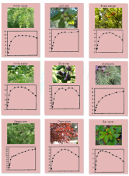
The horizontal axis varies from no light (night, intensity 0) to the maximum intensity of light during the day (approximately at midday). Numbers in the vertical axis represent the net amount of CO₂ each square metre of plant can fix per second.
- Broadly speaking, what are the graphs telling you about the relationship between light intensity and CO₂ absorption?

- Cut out the cards (picture + graph) and try to group them according to common features. Explain why you have chosen these groups.

- Could you explain in more detail the common features of the relationship between light intensity and CO₂ absorption for the plants you have grouped together?

- Why are there negative values on the graphs (vertical axis)?

Cork oak

Bitter orange

White poplar

Olive tree

Stone pine

Aleppo pine

Cherry plum

Bay laurel

Honey locust

Worksheets for task 5
Worksheet 5.1
Paste or sketch here a picture of the tree you will work with and sketch an approximation of its form using one or a combination of geometric forms (cylinder, cone, sphere, etc.).

Surface area of the tree: show workings for your calculations here:
Worksheet 5.2
The next table shows the maximum amount of CO₂ a plant can fix per square metre of leaves and per second.

Plant | Maximum rate in mg of CO₂ / m² s
Honey locust (Gleditsiatriacanthos) | 0.42
White poplar (Populus alba) | 0.32
Olive tree (Oleaeuropaea) | 0.54
Cherry plum (Prunuscerasifera var. pisardii) | 0.23
Bay laurel (Laurusnobilis) | 0.16
Bitter orange (Citrus aurantium) | 0.39
Holm oak (Quercus ilex) | 0.38
Aleppo pine (Pinushalepensis Mill.) | 0.71
Stone pine (Pinuspinea) | 0.48
Cork oak (Quercussuber) | 0.39

Estimate how much CO₂ your tree could absorb in one day, in one month and in one year.

Worksheets for task 6
Worksheet 6.1
1st statement: “One tree included, for free”.
The tree will compensate for the CO₂ emissions of your car in its first 20,000 kilometres of use.

Worksheet 6.2
2nd statement: “Optional CO₂ neutral pack”.
Between 9 and 14 trees will be planted to compensate for the pollution caused by your car for each 20,000 km travelled.

